Lab Submission: 5

Student Name: Michael Daly

Course and Section: CST8215 – 362

========================================================================

Lab 5 – Correcting models adding primary key, foreign keys and associative entities

You will be using postgres, PGAdmin and PGModeler for this Lab

Download the Lab 5 DDL and Lab 5 DML files to your laptop

Grading: Lab 5 is worth 10 marks

========================================================================

Step 1 -- Run the Lab 5 DDL and Lab 5 DML statements into postgres using PGAdmin. (1 mark)

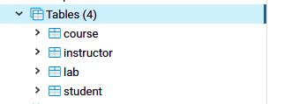

Step 2 - Using PGModeler, reverse engineer only these new tables into a physical data model. (1 mark)

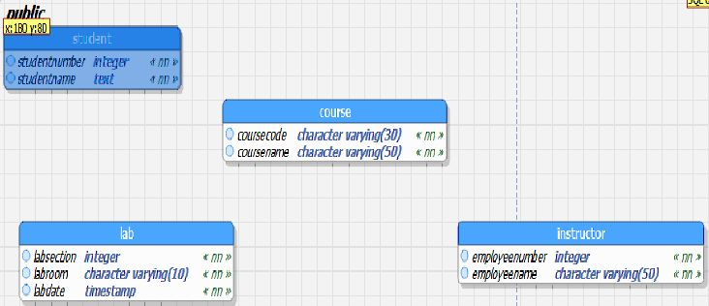

Step 3 - Using PGModeler, apply the corrections to the adding primary and foreign keys as required.

When you are going through the process of determining the ‘parent/child’ relationships remember

to ask yourself question ‘can table A have one or more rows in Table B’? This is where you will

encounter a **many-to-many** relationship. Where table A will have 1 to many rows in Table B but

table B can have 1 to many rows in Table A (associative entity). Hint, you have one in this set of

tables and you need to identity it. Once your physical model seems to be correct then…. (4 marks)

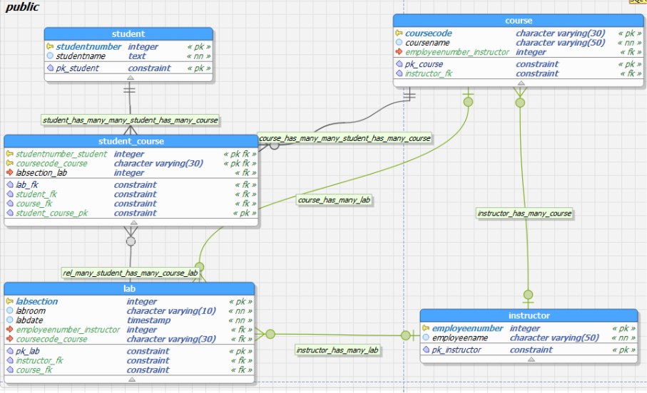

Step 4 - Export only those tables in this diagram and save the new DDL script for review. Then using

PGAdmin, copy/paste your new DDL script into your Query Tool. (2 marks)

TIP -- Remember to create all the tables before running the statements that create the foreign keys

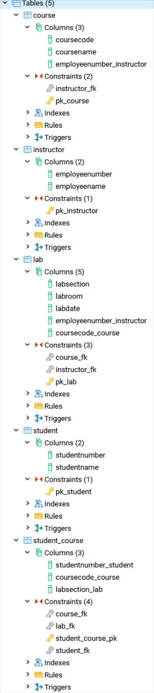

Step 5 - Once your DDL has run completely successfully, then you can begin populating the tables. (2 marks)

TIP - remember that you need to populate 'parent' tables before 'child' tables

